Experiment-6

Aim
To perform image erosion on an input image using the erosion function in OpenCV.

Procedure
- Import the OpenCV library.
- Read the input image using cv2.imread().
- Convert the image into grayscale.
- Create a kernel using np.ones().
- Apply erosion using cv2.erode().
- Display the original and eroded images.

Code
import cv2import numpy as np
img = cv2.imread("image.jpg")
gray = cv2.cvtColor(img, cv2.COLOR_BGR2GRAY)
kernel = np.ones((5, 5), np.uint8)
eroded = cv2.erode(gray, kernel, iterations=1)
cv2.imshow("Original Image", gray)cv2.imshow("Eroded Image", eroded)
cv2.waitKey(0)cv2.destroyAllWindows()

Sample Input
An image named image.jpg.

Sample Output
The original grayscale image and an eroded image in which bright foreground regions become smaller.
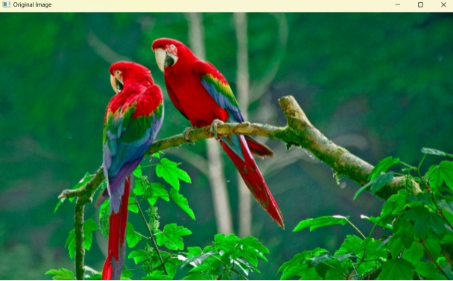
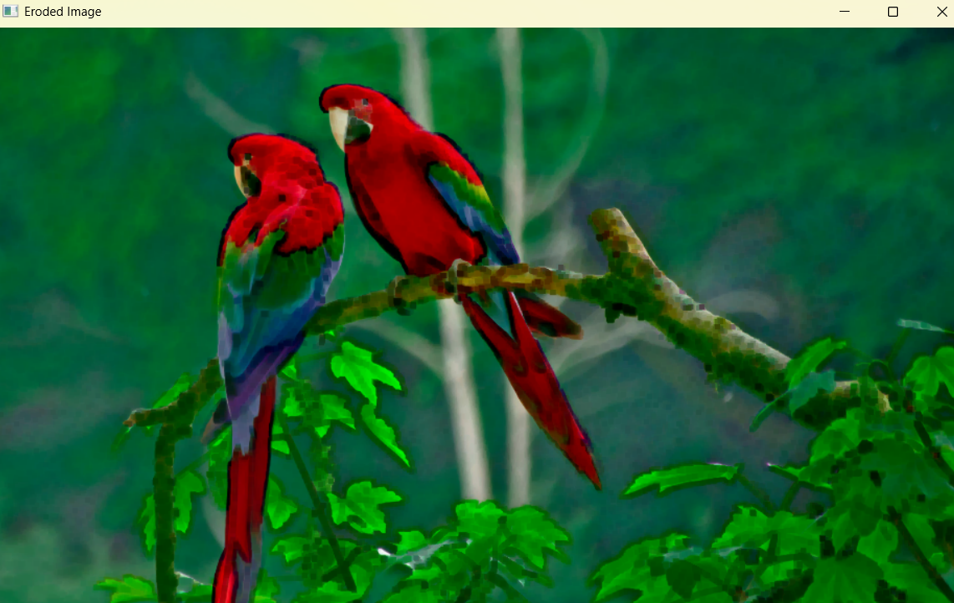

Result
Thus, image erosion was successfully performed using Python and OpenCV.

